Wavelet-Transform-based Phase Matching for
Tropospheric Retrieval in
GNSS Radio Occultation

Jonghyeon Park, Jaehee Chang and Jiyun Lee
Korea Advanced Institute of Science and Technology

BIOGRAPHY

Jonghyeon Park is a M.S. student in Aerospace Engineering at Korea Advanced Institute of Science and Technology (KAIST) in South Korea and holds a B.S. degree in Aerospace Engineering with a double major in Electrical Engineering from the same institution. His research interests focus on remote sensing of the atmosphere and ionosphere using GNSS radio occultation (RO).

ABSTRACT

The phase matching (PM) method is widely employed in Global Navigation Satellite System (GNSS) radio occultation (RO) retrievals to derive bending angles under atmospheric multipath conditions. In the lower troposphere, however, horizontal refractivity gradients can cause impact multipath where multiple bending angle solutions correspond to a single impact parameter and lead to large retrieval uncertainty. Existing quality control (QC) approaches typically use short-time Fourier transform (STFT) spectral analysis to identify impact multipath regions by measuring the local spectral width (LSW), an indicator of spectral distribution spread. However, the fixed time-frequency window inherent to STFT imposes a fundamental resolution trade-off that limits simultaneous high vertical and spectral resolution. To address this limitation, we propose a wavelet-transform-based phase matching (WTPM) technique that enables multi-resolution analysis in both the time and frequency domains. Applied to COSMIC-2 RO measurements, WTPM achieves 1 m impact parameter resolution with scale-dependent bending angle resolution ranging from 0.4 to 572 μrad across the 0-40 mrad domain, compared to the uniform resolution of about 743 μrad of STFT. The improved resolution enables direct identification and separation of multi-valued bending angles as well as detection of regions with large uncertainty due to impact multipath. Statistical validation against collocated European Centre for Medium-Range Weather Forecasts (ECMWF) analysis profiles demonstrates that WTPM reduces the mean relative bending angle bias at 2-10 km by approximately 10.4% relative to conventional PM. The results suggest that WTPM provides effective impact multipath mitigation through inherent QC based solely on wavelet spectral analysis, improving bending angle retrieval accuracy for numerical weather prediction applications.

Introduction

As Global Navigation Satellite System (GNSS) signals propagate through the atmospheric limb to low Earth orbit (LEO) satellites, they experience ray path bending and delay due to atmospheric refractivity gradients. The GNSS radio occultation (GNSS-RO) technique utilizes these effects to retrieve vertical profiles of refractivity for atmospheric sounding (Kursinski et al., 1997). The primary observable in GNSS-RO is the carrier phase delay accumulated along the ray path, from which the Doppler frequency shift of the transmitted signal is obtained. By combining the measured Doppler shift with precise satellite positions and velocities, the impact parameter, which is defined as the closest approach distance of the asymptotic ray path to the local center of curvature, and the corresponding atmospheric bending angle can be determined. The resulting bending angle profiles are then inverted to obtain refractivity as a function of altitude using Abel inversion.

In the stratosphere and upper troposphere, where atmospheric refraction is moderate, the signal propagation can be approximated by a single ray path linking the transmitter and receiver, allowing an unambiguous mapping from instantaneous frequency to bending angle. In the moist lower troposphere, however, moisture-induced refractivity irregularities often produce atmospheric multipath, yielding several concurrent ray paths (Gorbunov & Gurvich, 1998; Sokolovskiy, 2001). The measured complex signal then represents a coherent superposition of ray contributions, making simple time differentiation of the composite phase insufficient to recover unique instantaneous frequencies (Jensen et al., 2003). To address this ambiguity, wave-optics-based retrieval techniques have been developed. The most widely adopted wave optics methods are those built on the Fourier integral operator (FIO) framework, including canonical transform (CT) (Gorbunov, 2002), full spectrum inversion (FSI) (Jensen et al., 2003), and phase matching (PM) (Jensen et al., 2004). The CT method is effective, but it requires back-propagation of the complex field to a straight reference line prior to transformation, which is computationally demanding. While the FSI method avoids explicit back-propagation, it is theoretically exact only for circular orbits, with corrections needed for elliptical orbits. The PM method is closely related to the FSI method but performs the transform directly along the receiver orbit, avoiding reliance on circular-orbit assumptions while identifying multipath. The PM approach is currently implemented in the standard neutral atmosphere RO inversion algorithm at the COSMIC Data Analysis and Archive Center (CDAAC) (Sokolovskiy, 2021).

The PM method, like other FIO-based techniques, assumes a spherically symmetric atmosphere, implying that the atmospheric refractivity varies solely as a function of radial distance. Under this assumption, the impact parameter remains invariant along each ray trajectory and serves as a unique ray coordinate (Kursinski et al., 1997). This ensures that bending angle is a single-valued function of impact parameter, uniquely determined by the frequency of the phase-transformed signal in the impact parameter domain. However, in the presence of horizontal refractivity gradients, the spherical symmetry assumption becomes invalid and the impact parameter varies along the propagation path (Gorbunov & Kornblueh, 2001; Healy, 2001). Consequently, the impact parameter may no longer represent a unique coordinate for identifying individual rays, as different rays can share the same impact parameter value at their respective tangent points (Gorbunov & Lauritsen, 2009). This leads to multiple bending angle solutions for a single impact parameter—referred to as impact multipath—introducing substantial uncertainty and potentially large errors in lower-tropospheric retrievals (Marquardt et al., 2016; Liu et al., 2018; Zou et al., 2019).

Several studies have proposed error estimation and quality assessment techniques for retrieved bending angles based on spectral analysis. For example, Liu et al. (2018) developed a quality control (QC) procedure using short-time Fourier transform (STFT) with a 0.5 km sliding window to compute spectrograms of the WO-transformed signal and the local spectral width (LSW), which characterizes the dispersion of the spectral distribution and indicates retrieval uncertainty. While the STFT is useful for identifying high-uncertainty regions driven by impact multipath, its fixed time-frequency window imposes a fundamental resolution trade-off between vertical localization and spectral resolution. As a result, direct bending angle retrieval from the STFT spectrogram remains challenging, and QC is typically limited to discarding all observations below the impact parameter where LSW exceeds a threshold (Liu et al., 2018). This approach can remove valid data below the cutoff and fails to detect localized impact multipath regions with LSW below the threshold. Alternative QC approaches based on numerical weather prediction (NWP) model simulations have been developed to identify impact multipath via ray-tracing analysis (Zou et al., 2019), but these methods depend on external model fields rather than the RO measurements themselves.

To overcome these limitations, we propose a wavelet-transform-based phase matching (WTPM) technique for high-resolution spectrogram analysis and bending angle retrieval. In contrast to the STFT, the continuous wavelet transform (CWT) implements multi-resolution analysis with adaptive scale-dependent windowing that narrows for small-scale (high-frequency) contents and widens for large-scale (low-frequency) contents (Mallat, 1989; Kumar & Foufoula-Georgiou, 1997). This enables simultaneous localization in both time and frequency domains (Daubechies, 1990), which correspond to impact parameter and bending angle coordinates after phase transform. We analyze the resolution performance of CWT-based spectrograms and demonstrate WTPM capabilities using COSMIC-2 RO observations. Finally, we compare WTPM with conventional PM and validate retrieved bending angles against collocated European Centre for Medium-Range Weather Forecasts (ECMWF) analysis profiles.

The remainder of this paper is organized as follows. Section 2 reviews the fundamental principles of PM and introduces the WTPM technique; Section 3 details the practical implementation of WTPM for processing atmospheric excess phase observations; Section 4 demonstrates the effectiveness of the proposed technique through case study analysis and comprehensive statistical comparisons with conventional PM, and conclusions are provided in Section 5.

Bending angle retrieval methodology

2.1 Phase Matching: Principle and Assumptions

We briefly review the conventional PM method (Jensen et al., 2004) for retrieving bending angles from complex GNSS-RO signals. In the presence of multipath propagation, the received complex field can be modeled as a superposition of geometric optics ray contributions:
$$\begin{aligned}V\left(t\right)=\sum_{m}{A_{m}\left(t\right)\exp{(iφ_{m}\left(t\right))}}\#\left(1\right)\end{aligned}$$
where $m$ denotes ray branches, $A_{m}(t)$ represents the amplitude, and $φ_{m}\left(t\right)$ is the accumulated carrier phase. In practice, $φ_{m}\left(t\right)$ is constructed as the sum of a vacuum geometric phase and an atmospheric excess phase arising from refractivity variations along the propagation path. The PM method decomposes this multipath field into contributions associated with specific impact parameters by correlating $V(t)$ with a reference phase function $φ_{0}(c,t)$ defined for impact parameter $c$:
$$\begin{aligned}φ_{0}\left(c,t\right)=k\left(\sqrt{r_{L}^{2}-c^{2}}+\sqrt{r_{G}^{2}-c^{2}}+cβ\left(c,t\right)\right)\#\left(2\right)\end{aligned}$$
$$\begin{aligned}β\left(c,t\right)=θ\left(t\right)-\arctan\left(\frac{\sqrt{r_{L}^{2}-c^{2}}}{c}\right)-\arctan\left(\frac{\sqrt{r_{G}^{2}-c^{2}}}{c}\right)\#\left(3\right)\end{aligned}$$
$$\begin{aligned}M\left(c\right)=\int_{t_{a}}^{t_{b}}{V\left(t\right)\exp\left(-iφ_{0}\left(c,t\right)\right)dt}\#\left(4\right)\end{aligned}$$
where $λ$ is the carrier wavelength, $k=2π/λ$ is the wavenumber, $r_{L}(t)$ and $r_{G}(t)$ are the receiver (LEO) and transmitter (GNSS) distances from the local center of curvature, and $θ(t)$ is the separation angle between satellites. This transform yields a representation in the impact parameter domain wherein contributions from different ray branches become separable. Substituting the multipath model (1) into (4) gives:
$$\begin{aligned}M\left(c\right)=\sum_{m}{\int_{t_{a}}^{t_{b}}{A_{m}\left(t\right)\exp\left(i\left[φ_{m}\left(t\right)-φ_{0}\left(c,t\right)\right]\right)dt}}\#\left(5\right)\end{aligned}$$
The integral can be evaluated using the stationary-phase approximation. For each $c$, only contributions from stationary-phase points contribute coherently to $M(c)$, while non-stationary contributions oscillate rapidly and largely cancel. We denote by $n$ the ray branch containing a stationary-phase point $t_{n}(c)$, defined as the time instant satisfying:
$$\begin{aligned}{\left.\frac{∂\left(φ_{n}(t)-φ_{0}\left(c,t\right)\right)}{∂t}\right|}_{t=t_{n}\left(c\right)}=0\#\left(6\right)\end{aligned}$$
Assuming $A_{n}(t)$ varies slowly near $t_{n}(c)$ and ${\ddot{φ}}_{n}\left(t_{n}\right)-{\ddot{φ}}_{0}(c,t_{n})≠0$, the approximation yields:
$$\begin{aligned}M\left(c\right)≈A_{n}\left(t_{n}\right)\sqrt{\frac{2πi}{\left|{\ddot{φ}}_{n}\left(t_{n}\right)-{\ddot{φ}}_{0}\left(c,t_{n}\right)\right|}}\exp\left(i\left[φ_{n}\left(t_{n}\right)-φ_{0}\left(c,t_{n}\right)\right]\right)=A_{s}\left(c\right)\exp\left(iu\left(c\right)\right)\#\left(7\right)\end{aligned}$$
The bending angle $α$ is then obtained directly from the phase $u(c)$ of the complex field in the impact parameter domain as:
$$\begin{aligned}α\left(c\right)=-\frac{1}{k}\frac{du(c)}{dc}\#\left(8\right)\end{aligned}$$
This derivative relationship shows that the bending angle represents the rate of phase variation with impact parameter, analogous to Doppler shift in the time domain.

Under the assumption of a spherically symmetric atmosphere, the ray geometry and corresponding bending angle are uniquely determined at each impact parameter. However, horizontal refractivity gradients and localized structures in the lower troposphere violate this assumption, so the impact parameter-bending angle relationship is no longer single-valued (Gorbunov & Kornblueh, 2001; Healy, 2001). As a result, multiple stationary-phase points can arise, leading to multiple bending angles associated with a single impact parameter (Marquardt et al., 2016). This ambiguity prevents straightforward bending angle retrieval through direct phase differentiation.

2.2 Wavelet-Transform-based Phase Matching (WTPM)

In the impact parameter domain, the bending angles can be interpreted as the frequency of the phase-transformed field, providing a natural basis for spectral analysis of $M(c)$. Conventional QC methods use STFT spectrograms and uncertainty metrics such as LSW, which quantifies the spectral dispersion of bending angle contributions. However, STFT’s fixed time-frequency window creates an inherent resolution trade-off that precludes simultaneous fine localization in impact parameter and high spectral resolution. This limitation is particularly problematic in the lower troposphere, where both sharp vertical resolution and accurate characterization of multi-component bending angle spectra are needed.

The continuous wavelet transform (CWT) mitigates the limitation of STFT by providing multi-resolution, scale-dependent windowing (Mallat, 1989). For a signal $f(t)$, the CWT is defined as:
$$\begin{aligned}W\left(λ,t\right)=\int_{-∞}^{∞}{f\left(u\right)ψ_{λ,t}^{*}\left(u\right)du }, λ>0\#\left(9\right)\end{aligned}$$
where
$$\begin{aligned}ψ_{λ,t}\left(u\right)=\frac{1}{\sqrt{λ}}ψ\left(\frac{u-t}{λ}\right)\#\left(10\right)\end{aligned}$$
denotes the mother wavelet generating a family of basis functions, $ψ^{*}$ is its complex conjugate, $W$ represents the wavelet coefficients, $λ$ is the scale parameter inversely related to frequency, and $t$ is the location parameter. Unlike STFT, which decomposes signals using fixed-width windows modulated by sinusoids (Gabor, 1946; Allen & Rabiner, 1977), CWT employs scale-adaptive wavelets with variable time-frequency localization, enabling improved resolution in both domains. This fundamental difference in time-frequency localization is illustrated in Figure 1. Fourier analysis provides high spectral resolution without localization, STFT produces uniform time–frequency tiling, while wavelet analysis produces adaptive tiling that narrows at high frequencies (small scales) and widens at low frequencies (large scales).

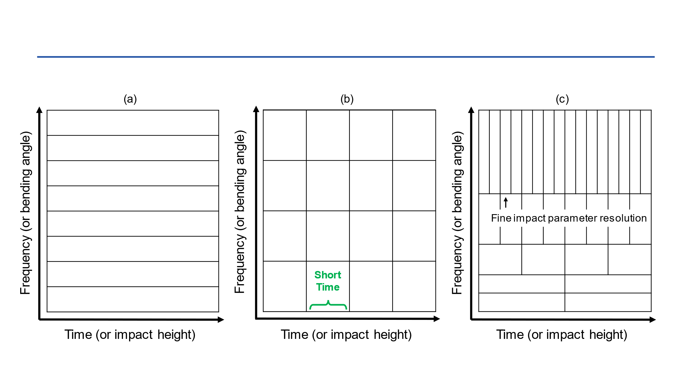
FIGURE 1 Comparison of time-frequency resolution characteristics among
(a) Fourier Transform, (b) Short-Time Fourier Transform, and (c) Wavelet Transform

In WTPM, we apply CWT to the phase-transformed field $M(c)$ as:
$$\begin{aligned}W\left(s,c\right)=\frac{1}{\sqrt{s}}\int_{-∞}^{∞}{M\left(c^{'}\right)ψ^{*}\left(\frac{c^{'}-c}{s}\right)dc^{'} }\#\left(11\right)\end{aligned}$$
where $c$ denotes impact parameter location, $c^{'}$ is the integration variable, and $s$ is the scale parameter associated with bending angle content. The bending angle $α$ corresponding to the scale $s$ is obtained as:
$$\begin{aligned}α=\frac{2πf_{c}}{sk}\#\left(12\right)\end{aligned}$$
where $f_{c}$ is the center frequency of the Morlet wavelet, and $k$ is the wavenumber of the signal. Applying this transformation, a wavelet scalogram $\left|W\left(α,c\right)\right|$ is obtained, providing two-dimensional energy distributions. The scale-dependent windowing of CWT provides higher impact parameter resolution in the lower troposphere where bending angles are large, and finer bending angle resolution in the upper troposphere where bending angles are smaller. This adaptive localization ensures accurate bending angle retrieval at high impact parameters while providing the fine vertical resolution required to localize impact multipath.
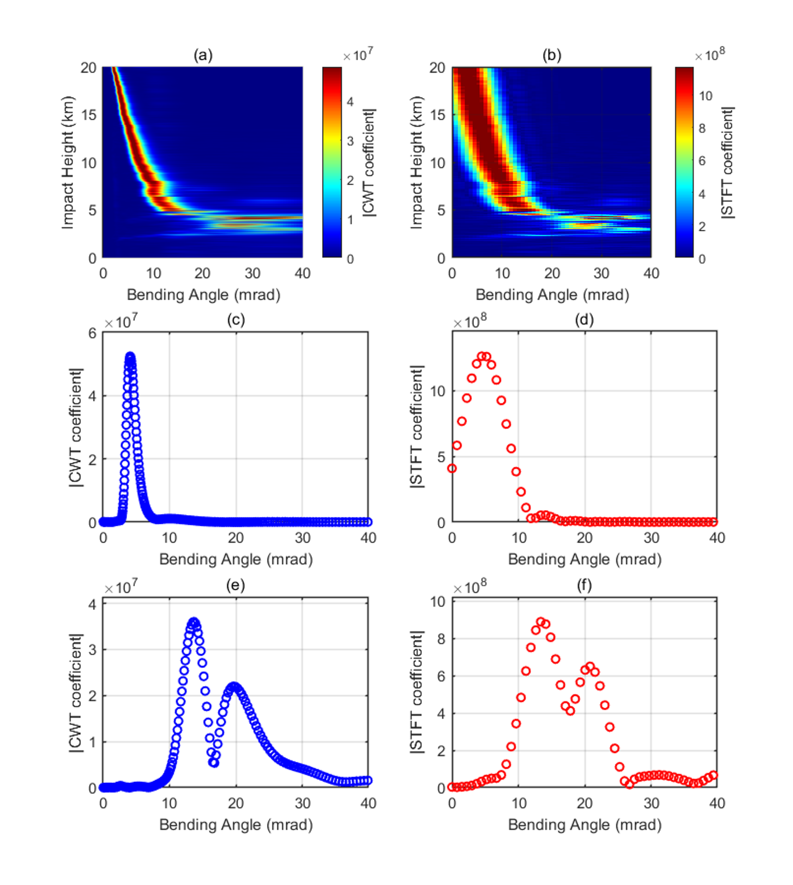
FIGURE 2 (a) CWT spectrogram, (b) STFT spectrogram using a 50 m window with 90% overlap
(c) CWT spectrum at 15 km, (d) STFT spectrum at 15 km, (e) CWT spectrum at 4.845 km, (f) STFT spectrum at 4.845 km

Figure 2 compares the impact parameter-bending angle representations obtained with CWT and STFT for an RO event affected by impact multipath. Panels (a) and (b) show $\left|W(α,c)\right|$ of the same phase-transformed field computed by CWT and STFT, respectively. The key difference lies in the bending angle resolution. Over the 0-40 mrad domain, CWT exhibits scale-dependent resolution ranging from 0.4 to 572 μrad, whereas the STFT provides a constant resolution of approximately 743 μrad determined by the 50 m sampling window and 1 m sampling interval. At 15 km shown in panels (c) and (d), both methods capture a single dominant component near 5 mrad. However, CWT resolves the peak more sharply with 60 μrad resolution near the peak location. In the impact multipath region at 4.845 km displayed in panels (e) and (f), CWT resolution broadens to 200-300 μrad around the multiple peaks near 12 and 20 mrad, yet remains substantially finer than the STFT resolution. This resolution contrast directly affects the separability of impact multipath component. In the impact multipath region, CWT resolves multiple coexisting components as distinct peaks, while the STFT tends to merge closely spaced components into broader, overlapping features, because it averages the spectrum over the full 50 m window. Accordingly, WTPM detects local maxima along the bending angle axis at each height and tracks them vertically, enabling direct retrieval of multi-valued structures and an intrinsic QC capability without relying on predefined thresholds or cutoff heights.

WTPM IMPLEMENTATION

This section describes the practical implementation of the WTPM algorithm for retrieving bending angle profiles from radio occultation measurements. The workflow consists of three steps: (1) constructing a wavelet scalogram from the phase-transformed field and identifying candidate bending angle components via peak detection, (2) forming vertically continuous bending angle trajectories by ridge tracking based on global dynamic programming (DP) optimizer, and (3) identifying impact multipath regions, excluding ambiguous samples, and interpolating across the resulting gaps to produce a single-valued bending angle profile.

3.1 Wavelet Scalogram Construction and Peak Detection

We apply the CWT to $M(c)$ obtained from Equation (5) using the analytic Morlet wavelet, a complex sinusoid modulated by a Gaussian envelope that is widely used in geophysical time series analysis (Torrence & Compo, 1998). To improve peak localization and reduce discretization error, we employ dense scale sampling with 48 voices per octave. The wavelet scalogram $\left|W(α,c)\right|$ is obtained by mapping the coefficient magnitude from scale $s$ to bending angle $α$, yielding a bending angle spectrum at each impact parameter $c$. Candidate bending angles are identified as local maxima along the $α$ axis using a standard peak detection routine (MathWorks, findpeaks). To suppress spurious detections caused by low-amplitude fluctuations, we apply an amplitude filter: peaks whose magnitude is below a fixed fraction of the maximum peak magnitude at that height are discarded. Specifically, with an amplitude threshold ratio $r_{th}$ (set to 0.1 in this study), only peaks satisfying the following condition are retained:
$$\begin{aligned}\left|W\left(α^{(k)},c\right)\right|≥r_{th}∙\max_{α}\left|W\left(α,c\right)\right|\#\left(13\right)\end{aligned}$$
As a result, for each impact parameter $c$, we obtain a discrete set of candidate bending angles $\left\{α^{(k)}\right\}$ with associated spectral amplitudes $\left\{\left|W\left(α^{(k)},c\right)\right|\right\}$, which serve as inputs to the subsequent ridge-tracking procedure.

3.2 Multi-Ridge Extraction via Dynamic Programming

The peak detection procedure in Section 3.1 identifies bending angle components independently at each impact parameter and therefore yields discrete sets of local spectral maxima. These candidates may include contributions from impact multipath, noise-induced spurious peaks, and intermittent or discontinuous features. Recovering physically consistent bending angle profiles requires connecting candidates across neighboring impact parameters to form vertically continuous trajectories—a process known as ridge extraction in time-frequency analysis (Delprat et al., 1992). A variety of ridge-extraction algorithms have been proposed for wavelet scalogram to track spectral ridges in the presence of noise and overlapping components. Among them, DP approaches are particularly effective because they cast ridge tracking as a global path-optimization problem on discrete candidate sets while naturally accommodating smoothness constraints with efficient recursion (Carmona et al., 1997; Iatsenko et al., 2016). When multiple components coexist at the same impact parameter, as in impact multipath, multi-ridge extraction is required (Carmona et al., 1998).

In this study, we adopt a DP-based formulation for multi-ridge extraction from the wavelet spectrogram of the phase-transformed field. Let $t=1, …, T$ index the sorted impact parameters $\left\{c^{(t)}\right\}$. At each $c^{(t)}$, peak detection yields candidate bending angles ${\left\{α_{k}^{\left(t\right)}\right\}}_{k=1}^{K_{t}}$ with corresponding spectral amplitudes $\left\{A_{k}^{(t)}\right\}=\left\{\left|W\left(α_{k}^{\left(t\right)},c^{\left(t\right)}\right)\right|\right\}$. A ridge is represented by an index sequence ${\left\{k_{t}\right\}}_{t=1}^{T}$ selecting one candidate at each $t$. We define the ridge score:
$$\begin{aligned}J\left(\left\{k_{t}\right\}\right)=\sum_{t=1}^{T}{log(A_{t}^{\left(k_{t}\right)}+ϵ)}-w_{F}\sum_{t=2}^{T}{\left|α_{t}^{\left(k_{t}\right)}-α_{t-1}^{\left(k_{t-1}\right)}\right|}-&w_{A}\sum_{t=2}^{T}{\left|\log{A_{t}^{\left(k_{t}\right)}}-\log{A_{t-1}^{\left(k_{t-1}\right)}}\right|}-w_{R}\sum_{t=1}^{T}{1_{V}(k_{t})}\#\left(14\right)\end{aligned}$$
$$\begin{aligned}1_{V}\left(k_{t}\right)=\left\{\begin{aligned}1,&& &&&&&if k_{t}∈V \\ 0,& &&&&& &if k_{t}∉V.\end{aligned}\right.\#\left(15\right)\end{aligned}$$
where $\log{(A_{t}^{\left(k_{t}\right)}+ϵ)}$ is the emission term that favors high-energy peaks. The continuity penalty weighted by $w_{F}$ discourages large bending angle jumps, while the amplitude-consistency penalty weighted by $w_{A}$ suppresses abrupt changes in peak magnitude between adjacent impact parameters. The reuse penalty weighted by $w_{R}$ discourages selecting candidates that have already been assigned to previously extracted ridges. The indicator $1_{V}\left(k_{t}\right)$ equals 1 if $k_{t}∈V$ and 0 otherwise, where $V$ denotes the set of previously used candidate indices. Maximizing $J\left(\left\{k_{t}\right\}\right)$ defines a global path-optimization problem solved efficiently via DP. For each candidate, we compute the maximum cumulative score over all ridge paths terminating at that location, yielding a formulation mathematically equivalent to the Viterbi algorithm (Forney, 1973). We extend conventional single-ridge tracking by introducing a reuse penalty that penalizes, but does not prohibit the reuse of candidates. This allows subsequent iterations to discover alternative trajectories when meaningful competing paths exist while naturally terminating when no additional distinct ridges are present. For this study, our goal is to detect the presence of impact multipath rather than resolve every individual component. Therefore, two iterations extracting up to two ridges are sufficient to identify impact multipath regions, even when three or more components coexist. The framework extends straightforwardly to additional iterations if complete separation of impact multipath is required.

The weight parameters were determined through empirical tuning to balance the contributions of different cost function terms based on ridge extraction performance. We iteratively adjusted $w_{F}$, $w_{A}$, and $w_{R}$ while evaluating impact multipath detection capability when impact multipath structure is evident in individual bending angle spectra at each impact parameter. The selection aimed to maintain continuous ridge trajectories without spurious fragmentation, successfully identify secondary ridges, and suppress tracking of transient spectral features. We set $w_{F}=50$, $w_{A}=0.35$, and $w_{R}=0.35$ for all profiles based on tuning performed on an independent subset of COSMIC-2 observations from four representative days spanning different seasons in 2024. Sensitivity analysis demonstrates that the algorithm’s performance is qualitatively robust to moderate parameter variations. However, extreme settings lead to degraded performance. Excessively large $w_{F}$ values fragment continuous ridges into disconnected segments, while excessively small values permit spurious jumps between unrelated spectral peaks. Similarly, excessive $w_{R}$ causes premature termination of the second iteration even when a distinct secondary ridge exists, whereas insufficient $w_{R}$ leads to duplicated extraction of the same ridge in both iterations.

3.3 Detection and Exclusion of Impact Multipath Regions

The multi-ridge extraction in Section 3.2 yields a set of vertically continuous bending angle trajectories, each corresponding to a distinct spectral component in the wavelet representation. When two or more ridges coexist at the same impact parameter, we interpret this as impact multipath. In such regions, selecting a single representative bending angle is intrinsically ambiguous, and current wave-optics-based retrievals generally cannot determine which component should be preferred on a physically robust basis (Gorbunov, 2002; Jensen et al., 2004). We therefore adopt a conservative strategy in which samples at impact parameters with multiple ridges are flagged as impact multipath and excluded from the final bending angle profile. This binary classification ensures that only unambiguous, single-valued bending angles are retained in the output profile. However, the removal of samples contaminated with impact multipath introduces gaps in the profile. To obtain a continuous bending angle profile suitable for subsequent Abel inversion and refractivity retrieval (Fjeldbo et al., 1971), we fill gaps using shape-preserving piecewise cubic Hermite interpolation (Fritsch & Carlson, 1980). Interpolation is applied only between valid samples within the retrieved impact parameter range; no extrapolation beyond the available profile extent is performed.

Results and discussion

In this study, we evaluate the performance of the WTPM technique using real RO measurements from the Constellation Observing System for Meteorology, Ionosphere, and Climate-2 (COSMIC-2) mission. COSMIC-2 consists of six low Earth orbit satellites, providing high-density RO coverage primarily over tropical and subtropical latitudes (Schreiner et al., 2020). Each COSMIC-2 satellite is equipped with dual occultation antennas, forward and backward, mounted on opposite sides of the spacecraft, allowing simultaneous tracking of both rising and setting occultations (Weiss et al., 2022). Atmospheric excess phase observations sampled at 50 Hz serve as the primary input for bending angle retrieval. For validation, the retrieved bending angles are statistically compared with reference profiles from ECMWF analyses and CDAAC operational bending angle product. To assess the specific improvement achieved by the wavelet-based approach, we also implement the conventional PM technique as described by Jensen et al. (2003) and Sokolovskiy (2021). The specific data products required for bending angle retrieval and validation are summarized in Table 1.

TABLE 1
Data Products for Bending Angle Retrieval and Validation
Type | File Format | Source
Atmospheric excess phase (50Hz) | conPhs | COSMIC Data Analysis and Archive Center (CDAAC)
Atmospheric profiles (RO retrieval) | atmPrf
ECMWF profiles | echPrf

We analyze COSMIC-2 RO measurements collected on five dates: 2 January, 1 March, 1 June, 1 September, and 1 December 2024. These dates are selected to provide seasonal diversity, ensuring that the validation dataset spans all four seasons and captures the full range of atmospheric variability. The CDAAC operational processing applies comprehensive QC procedures to assign quality flags to individual profiles (Schreiner et al., 2020; Sokolovskiy, 2021). Profiles flagged as poor quality—indicating tracking errors, excessive phase noise, or retrieval failures—were systematically excluded.

4.1 Case Study

To evaluate the performance of the WTPM technique under varying atmospheric conditions, we examine two representative occultation events. The first case demonstrates the method's capability to identify and resolve impact multipath structures in regions with strong horizontal refractivity gradients, while the second case validates its stability and consistency when applied to profiles without impact multipath contamination. Together, these cases provide complementary insights into the operational characteristics of the wavelet-based approach and its advantages over the conventional PM method.

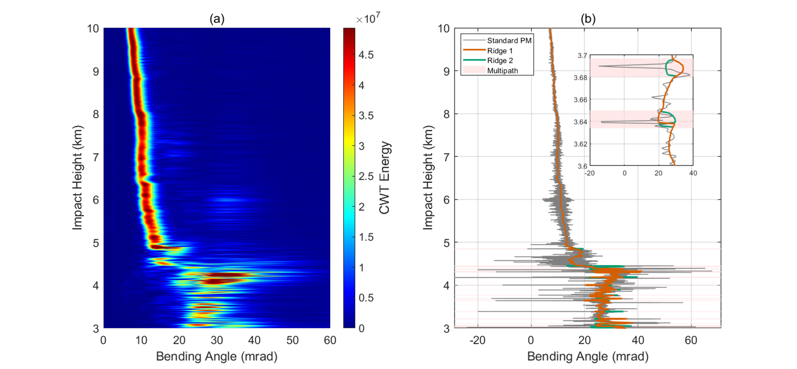
FIGURE 3 Multi-ridge extraction results for Case 1. (a) CWT scalogram. (b) Extracted Ridges (Ridge 1 in orange, Ridge 2 in green) overlaid on the raw PM profile (gray). Shaded Regions mark impact multipath regions where ridge separation occurs. Inset: magnified view of the lower-tropospheric region.

Case 1 corresponds to an occultation event recorded on January 2, 2024 from 00:00:54 to 00:02:58 Universal Time (UT) (Figure 3). Panel (a) presents the CWT scalogram, revealing the spectral decomposition in the impact parameter-bending angle domain, where bright regions indicate high spectral energy. Panel (b) presents the bending angle ridges extracted from the scalogram, overlaid on the “raw” (unfiltered) profile derived by conventional PM. Two distinct ridges are identified by the multi-ridge extraction algorithm, with ridge 1 in orange and ridge 2 in green, overlaid on the raw PM bending angle profile shown in gray. The shaded regions indicate areas flagged as impact multipath based on ridge separation. The inset zooms into the 3.6–3.7 km impact height range, revealing clear separation between the two ridges in the impact multipath zone. Within the regions affected by impact multipath, the raw PM profile exhibits irregular spikes that deviate from the dominant bending angle components, producing unreliable values even after smoothing. These artifacts result from interference between multiple bending angle contributions when applying direct phase differentiation. In contrast, the extracted ridges represent smooth and physically consistent trajectories corresponding to the individual ray paths that comprise the observed interference pattern.

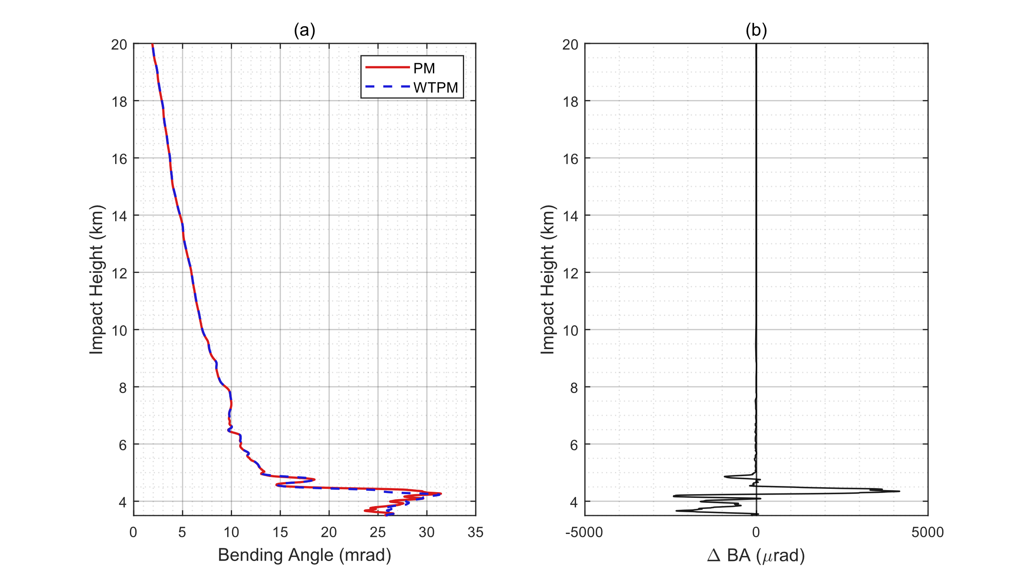
FIGURE 4 Comparison of WTPM and conventional PM bending angle retrievals for Case 1 shown in Figure 3.
(a) Bending angle profiles from PM (solid red) and WTPM (dashed blue). (b) Difference between WTPM and PM ($∆$BA = WTPM – PM).

Figure 4 compares the final bending angle profiles retrieved by PM and WTPM after applying the same filtering procedures as implemented in the standard CDAAC neutral atmosphere inversion algorithm (Sokolovskiy, 2021). This ensures that differences between the methods reflect the impact multipath handling strategy rather than subsequent processing choices. Panel (a) shows the full vertical profiles covering 3 to 20 km in impact height. Above 5 km, the two methods produce nearly identical results throughout the profile. This agreement confirms that the wavelet-based spectral analysis does not introduce systematic biases or spurious features when the single-valued assumption is satisfied. Between 3 and 5 km, however, larger differences emerge between the two methods due to the presence of impact multipath. In these regions, WTPM excludes samples affected by impact multipath and applies interpolation, whereas PM attempts direct retrieval through phase differentiation. Panel (b) presents the bending angle difference, quantifying the discrepancy between the two methods. Above 5 km, the mean absolute difference is 15.7 μrad, while below 5 km it increases to 1131.4 μrad. Sharp spikes associated with the impact multipath regions are evident in the 3–5 km range, where differences reach up to 4176.4 μrad.

Case 2 represents an occultation recorded on January 2, 2024 from 00:03:29 to 00:05:27 UT. The wavelet scalogram for this event displays a single continuous ridge from the upper troposphere through the lower troposphere, with no impact parameters flagged for impact multipath exclusion. The final WTPM profile is therefore derived entirely from direct spectral peak extraction without interpolation. Figure 5(a) compares the bending angle profiles retrieved by PM and WTPM, and the CDAAC operational product. All three profiles exhibit strong agreement over the full 4–20 km range, indicating that the wavelet-based spectral analysis converges to the same solution as the phase-derivative approach. This consistency is further quantified in Figure 5(b)–(d), which show the bending angle differences $∆$BA between each pair of profiles: WTPM – PM, PM – CDAAC, WTPM – CDAAC, respectively. Over the full range, the corresponding mean absolute differences are 14.1 μrad, 42.7 μrad, and 43.0 μrad, confirming that both retrievals remain consistent with the operational reference.

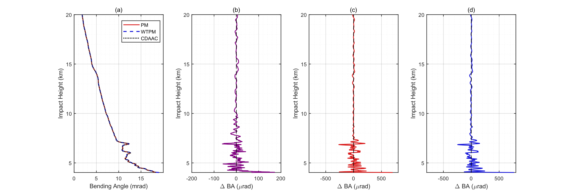
FIGURE 5 Bending angle profile comparison for Case 2. (a) Retrieved profiles from conventional PM (solid red), WTPM (dashed blue), and CDAAC operational processing (dotted black). (b) Difference between WTPM and PM (WTPM – PM). (c) Difference between PM and CDAAC (PM – CDAAC). (d) Difference between WTPM and CDAAC (WTPM – CDAAC)

4.2 Statistical Study

A statistical evaluation of the WTPM technique was conducted against ECMWF analysis bending angles and CDAAC operational products, with conventional PM results included for comparison. The evaluation dataset comprises 8,573 COSMIC-2 occultation profiles randomly sampled from the full collection, spanning a wide range of latitudes and atmospheric conditions. All profiles were processed using identical filtering and QC settings.

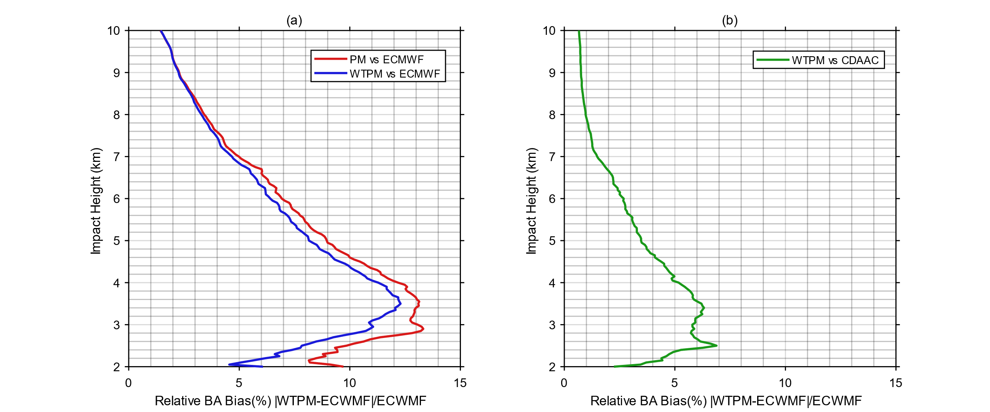
FIGURE 6 Relative bending angle bias (%) between bending angle products. (a) PM versus ECMWF (red) and WTPM versus ECMWF (blue). (b) WTPM versus CDAAC (green). Statistics aggregated over 8,573 occultations collected across 2 January, 1 March, 1 June, 1 September, 1 December 2024.

Figure 6 shows the relative bending angle bias $($i.e., $\left|WTPM-ECWMF\right|/ECWMF×100\%)$ as a function of impact height. Panel (a) compares PM and WTPM with ECMWF over the 2–10 km impact height range. In the upper portion of this range, the two methods exhibit nearly identical bias profiles, indicating that WTPM does not degrade retrievals where spherical symmetry is approximately valid and impact multipath is uncommon. In the lower portion, however, the PM bias increases steadily with decreasing impact height, while WTPM maintains substantially lower bias throughout. Over 2–10 km, the mean relative bias against ECMWF decreases from 11.55% (PM) to 10.27% (WTPM), a reduction of 1.28 percentage points, corresponding to a relative reduction of 10.4%. This improvement demonstrates the benefit of explicit multipath identification and conservative exclusion over attempting to retrieve bending angles in regions where the retrieval assumptions are fundamentally violated.

Panel (b) compares WTPM retrievals against CDAAC operational products over the same impact height range. CDAAC processing employs sophisticated QC and adaptive filtering, representing the current operational standard for radio occultation retrieval. Across the entire profile, the relative bias remains below 7%, with a mean relative bias of 2.65% over the 2–10 km range, indicating close agreement with the operational standard. This consistency confirms that WTPM achieves operational quality standards (Schreiner et al., 2019) while using an independent wavelet-based approach, demonstrating the reliability of WTPM.

ConcLUsion

This study proposed the WTPM technique for high-resolution bending angle retrieval under impact multipath conditions in GNSS radio occultation. Our approach employs CWT to achieve adaptive scale-dependent resolution in both impact parameter and bending angle domains. The adaptive resolution of CWT offers complementary benefits compared to STFT’s fixed-window analysis. In the upper troposphere where bending angles are small and single-valued, CWT maintains fine spectral resolution, enabling accurate retrieval of the unique bending angle at each impact parameter. In the lower troposphere where horizontal refractivity gradients cause impact multipath, i.e., multiple bending angle solutions for a single impact parameter, CWT provides sufficient impact parameter localization to identify the vertical extent of these ambiguous regions. Through multi-ridge extraction using DP with reuse penalty constraints, WTPM identifies and excludes impact multipath regions while preserving physically meaningful retrievals in single-valued regions.

Statistical validation was performed against collocated ECMWF analysis profiles using 8,573 COSMIC-2 observations collected across five dates in 2024. The results demonstrate that WTPM achieves a 10.4% relative reduction in the mean relative bending angle bias compared to conventional PM at impact heights of 2-10 km. Furthermore, WTPM shows close agreement with CDAAC operational products, demonstrating its potential for operational implementation to improve tropospheric retrievals.

Future efforts will include establishing a physically robust criterion for selecting the most representative ray component within impact multipath regions, and potentially leveraging the currently discarded ray components to characterize horizontal atmospheric inhomogeneities. Additionally, we aim to improve the multi-ridge tracking algorithm through the refinement of the cost function weights and exploration of optimization strategies beyond the present DP framework.

ACKNOWLEDGMENTS

This research was supported by funding from the Korea government (KASA, Korea AeroSpace Administration) (grant number RS-2022-NR067077) and by the National Research Foundation of Korea (NRF) grant funded by the Korea government (MSIT) (No. RS-2025-02213804).

REFERENCES

Kursinski, E. R., Hajj, G. A., Schofield, J. T., Linfield, R. P., & Hardy, K. R. (1997). Observing Earth's atmosphere with radio occultation measurements using the Global Positioning System. Journal of Geophysical Research: Atmospheres, 102(D19), 23429-23465. https://doi.org/10.1029/97JD01569

Gorbunov, M. E., & Gurvich, A.S. (1998). Multipath effects in the lower troposphere. Journal of Geophysical Research, 103(D12), 13819-13826. https://doi.org/10.1029/98JD00806

Sokolovskiy, S. V. (2001). Modeling and inverting radio occultation signals in the moist troposphere. Radio Science, 36(3), 441-458. https://doi.org/10.1029/1999RS002273.

Jensen, A. S., Lohmann, M. S., Benzon, H.-H., & Nielsen, A. S. (2003). Full spectrum inversion of radio occultation signals. Radio Science, 38(3), 1040. https://doi.org/10.1029/2002RS002763

Gorbunov, M. E. (2002). Canonical transform method for processing radio occultation data in the lower troposphere. Radio Science, 37(5), 1076. https://doi.org/10.1029/2000RS002592

Jensen, A. S., Lohmann, M. S., Nielsen, A. S., & Benzon, H.-H. (2004). Geometrical optics phase matching of radio occultation signals. Radio Science, 39(3), RS3009. https://doi.org/10.1029/2003RS002899

Sokolovskiy, S. (2021). Standard RO inversions in the neutral atmosphere 2013-2020: Processing steps and explanation of data. UCAR COSMIC Data Analysis and Archive Center. https://www.cosmic.ucar.edu/sites/default/files/2021-09/cdaac_ro_retrieval_description_v1.pdf

Gorbunov, M. E., & Kornblueh, L. (2001). Analysis and validation of GPS/MET radio occultation data. Journal of Geophysical Research: Atmospheres, 106(D15), 17161-17169. https://doi.org/10.1029/2000JD900816

Healy, S. B. (2001). Radio occultation bending angle and impact parameter errors caused by horizontal refractive index gradients in the troposphere: A simulation study. Journal of Geophysical Research: Atmospheres, 106(D11), 11875-11889. https://doi.org/10.1029/2001JD900050

Gorbunov, M. E., and K. B. Lauritsen (2009). Error estimate of bending angles in the presence of strong horizontal gradients, in New Horizons in Occultation Research, edited by A. Steiner et al., pp. 17–26, Springer, Heidelberg, Germany. https://doi.org/10.1007/978-3-642-00321-9_2

Marquardt, C., Notarpietro, R., von Engeln, A., Andres, Y., & Butenko, L. (2016). Wave optics and multipath in the impact parameter domain. OPAC-IROWG 2016 Workshop. https://wegccon.uni-graz.at/opacirowg2016/data/public/files/opacirowg2016_Christian_Marquardt_presentation_223.pdf

Liu, H., Kuo, Y.-H., Sokolovskiy, S., Zou, X., Zeng, Z., Hsiao, L.-F., & Ruston, B. C. (2018). A quality control procedure based on bending angle measurement uncertainty for radio occultation data assimilation in the tropical lower troposphere. Journal of Atmospheric and Oceanic Technology, 35(11), 2139-2157. https://doi.org/10.1175/JTECH-D-17-0224.1

Zou, X., Liu, H., & Kuo, Y.-H. (2019). Occurrence and detection of impact multipath simulations of bending angle quality control of bending angle simulations (NOAA Technical Report NESDIS 152). NOAA National Environmental Satellite, Data, and Information Service. https://repository.library.noaa.gov/view/noaa/57088/noaa_57088_DS1.pdf

Mallat, S. G. (1989). A theory for multiresolution signal decomposition: The wavelet representation. IEEE Transactions on Pattern Analysis and Machine Intelligence, 11(7), 674-693. https://doi.org/10.1109/34.192463

Kumar, P., & Foufoula-Georgiou, E. (1997). Wavelet analysis for geophysical applications. Reviews of Geophysics, 35(4), 385-412. https://doi.org/10.1029/97RG00427

Daubechies, I. (1990). The wavelet transform, time-frequency localization and signal analysis. IEEE Transactions on Information Theory, 36(5), 961-1005. https://doi.org/10.1109/18.57199

Gabor, D. (1946). Theory of communication. Journal of the Institution of Electrical Engineers - Part III: Radio and Communication Engineering, 93(26), 429-457. https://doi.org/10.1049/ji-3-2.1946.0074

Allen, J. B., & Rabiner, L. R. (1977). A unified approach to short-time Fourier analysis and synthesis. Proceedings of the IEEE, 65(11), 1558-1564. https://doi.org/10.1109/PROC.1977.10770

Torrence, C., & Compo, G. P. (1998). A practical guide to wavelet analysis. Bulletin of the American Meteorological Society, 79(1), 61-78. https://doi.org/10.1175/1520-0477(1998)079<0061:APGTWA>2.0.CO;2

Delprat, N., Escudié, B., Guillemain, P., Kronland-Martinet, R., Tchamitchian, P., & Torrésani, B. (1992). Asymptotic wavelet and Gabor analysis: Extraction of instantaneous frequencies. IEEE Transactions on Information Theory, 38(2), 644-664. https://doi.org/10.1109/18.119728

Carmona, R., Hwang, W. L., & Torrésani, B. (1997). Characterization of signals by the ridges of their wavelet transforms. IEEE Transactions on Signal Processing, 45(10), 2586-2590. https://doi.org/10.1109/78.640725

Carmona, R., Hwang, W. L., & Torrésani, B. (1998). Multi-ridge detection and time-frequency reconstruction. IEEE Transactions on Signal Processing, 47(2), 480-492. https://doi.org/10.1109/78.740131

Iatsenko, D., McClintock, P. V. E., & Stefanovska, A. (2016). Extraction of instantaneous frequencies from ridges in time-frequency representations of signals. Signal Processing, 125, 290-303. https://doi.org/10.1016/j.sigpro.2016.01.024

Forney, G. D. (1973). The Viterbi algorithm. Proceedings of the IEEE, 61(3), 268-278. https://doi.org/10.1109/PROC.1973.9030

Fjeldbo, G., Kliore, A. J., & Eshleman, V. R. (1971). The neutral atmosphere of Venus as studied with the Mariner V radio occultation experiments. The Astronomical Journal, 76, 123-140. https://doi.org/10.1086/111096

Fritsch, F. N., & Carlson, R. E. (1980). Monotone piecewise cubic interpolation. SIAM Journal on Numerical Analysis, 17(2), 238-246. https://doi.org/10.1137/0717021

Schreiner, W. S., Weiss, J. P., Anthes, R. A., Braun, J., Chu, V., Fong, J., Hunt, D., Kuo, Y.-H., Meehan, T., Serafino, W., Sjoberg, J., Sokolovskiy, S., Talaat, E., Wee, T. K., & Zeng, Z. (2020). COSMIC-2 radio occultation constellation: First results. Geophysical Research Letters, 47(4), e2019GL086841. https://doi.org/10.1029/2019GL086841

Weiss, J.-P., Schreiner, W. S., Braun, J. J., Xia-Serafino, W., & Huang, C.-Y. (2022). COSMIC-2 mission summary at three years in orbit. Atmosphere, 13(9), 1409. https://doi.org/10.3390/atmos13091409

Schreiner, W. S., et al. (2019). Overview of the COSMIC-2 mission. Poster presented at AGU Fall Meeting 2019, San Francisco, CA. Retrieved from https://data.cosmic.ucar.edu/gnss-ro/cosmic2/provisional/references/schreiner_2019.pdf

